Ms. Coles
K Class Schedule
2019-2020
8:45-9:15 | 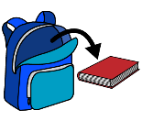 | Arrive/Unpack/Breakfast
9:15-9:40 |  | Positivity Project/Calendar
9:40-10:40 |  | Centers
10:40-11:00 | 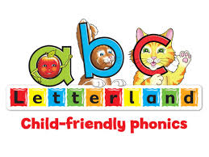 | Letterland
11:00-11:20 |  | Word Work
11:25-11:55 |  | Recess
12:00-1:00 | 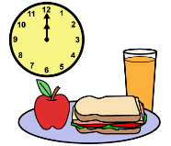 | Lunch
1:05-1:35 | 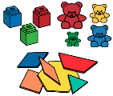 | Math Centers  (PALS 5th grade)
1:35-1:55 |  | Storytime
1:55-2:05 |  | Writing
2:00-2:25 |  | Track
2:30-3:00 | 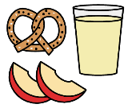/ | Snack/Pack Bookbag
3:05-3:35 |  | Specials  (PALs 4th grade)
3:35 |  | Dismissal

